• MAE: The average size of prediction errors, without considering their direction.
• RMSE: Like MAE, but it gives more weight to large errors.
• R²: Shows how well the model explains the data (closer to 1 is better).
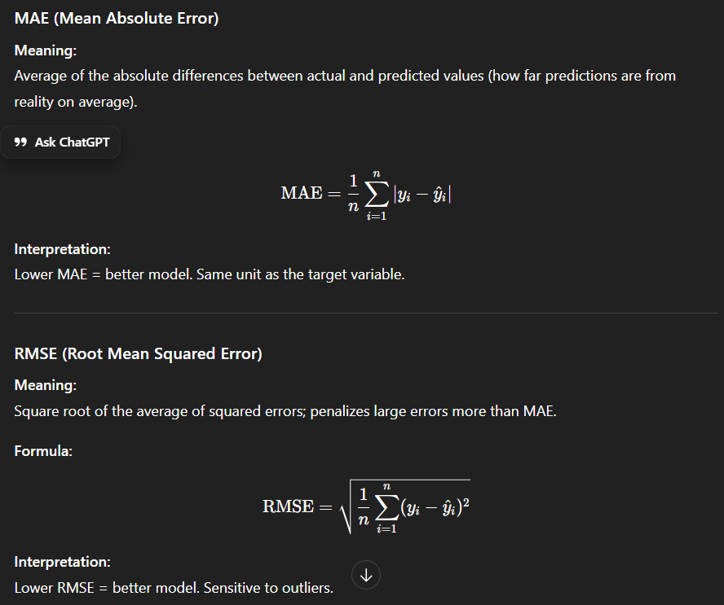
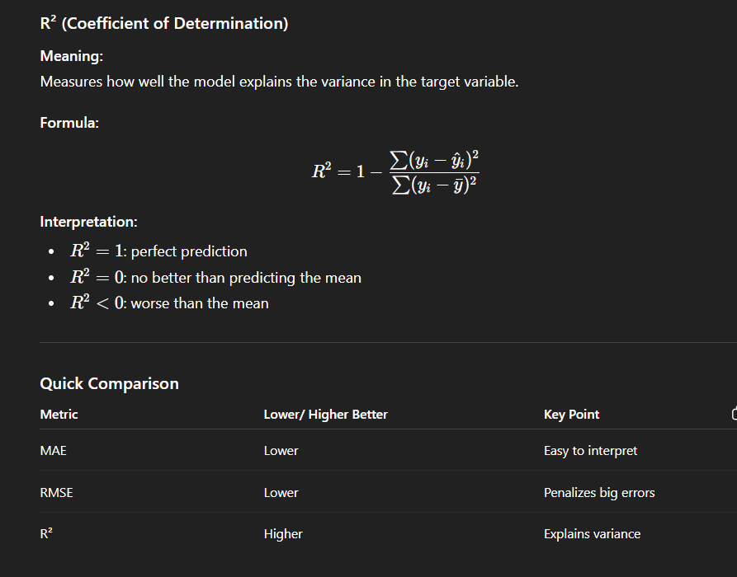
While showing demo show general then smoker
--------------------------------------------------------------------------------------------------------------------------------------
Gradient boosting : https://youtu.be/TyvYZ26alZs?si=4j5nqVfFcZEVqZWF
Linear regression: https://youtu.be/zUQr6HAAKp4?si=Tywy8tGr7O_LYE5o
Random Forest: https://youtu.be/v6VJ2RO66Ag?si=1EpjluOgvZj_Upf8

How the Model is Trained (Backend):
- The insurance dataset with 1,338 records is loaded, containing features like age, BMI, smoking status, and actual insurance charges.
- Categorical features (sex, smoker, region) are converted to numbers using Label Encoding so the machine learning algorithm can process them.
- The data is split into 80% training and 20% testing sets, then fed into a Gradient Boosting Regressor which learns patterns between health factors and insurance costs.
- The trained model achieves 88% accuracy (R² score) and is saved as a .pkl file for later use in predictions.
What Happens When User Gives Input:
- User enters their health details (age, sex, BMI, children, smoking status, region) through the interface.
- The input is converted into the same numerical format used during training and arranged as a single row array.
- The saved model (.pkl file) is loaded and uses its learned patterns to predict the insurance charge in USD.
- The predicted USD amount is converted to INR (multiplied by 83) and displayed as both yearly and monthly costs to the user.
what about gradient boosting regressor and how is it better than other algorithms
Detailed Steps When User Gives Input:
Step 1: User Input Collection
- User enters: Age=30, Sex=Male, BMI=25.5, Children=2, Smoker=Yes, Region=Northeast
- Interface validates the input (age between 18-64, BMI positive, etc.)
Step 2: Data Preprocessing (Same as Training)
- Categorical values are encoded: Male→1, Yes(smoker)→1, Northeast→0
- Input becomes numerical array: [30, 1, 25.5, 2, 1, 0]
- No mean/averaging happens here - it's direct conversion
Step 3: Model Loading & Prediction
- The saved .pkl file containing the trained Gradient Boosting model is loaded into memory
- Input array is reshaped to [[30, 1, 25.5, 2, 1, 0]] (2D format required by model)
- This is where the magic happens - NOT using dataset mean:
Step 4: How the Model Actually Predicts (Tree-Based Logic):
- The model has 200 decision trees learned during training
- Each tree asks questions like: "Is smoker=1?" → Yes → "Is BMI>25?" → Yes → "Is age>25?" → Yes → Predicts +$15,000
- Tree 1 might predict $12,000, Tree 2 corrects to +$3,000, Tree 3 adds +$800, etc.
- All 200 predictions are weighted and summed: Final = (0.05 × Tree1) + (0.05 × Tree2) + ... = $35,420
- It does NOT calculate mean of training data - it follows the learned decision rules
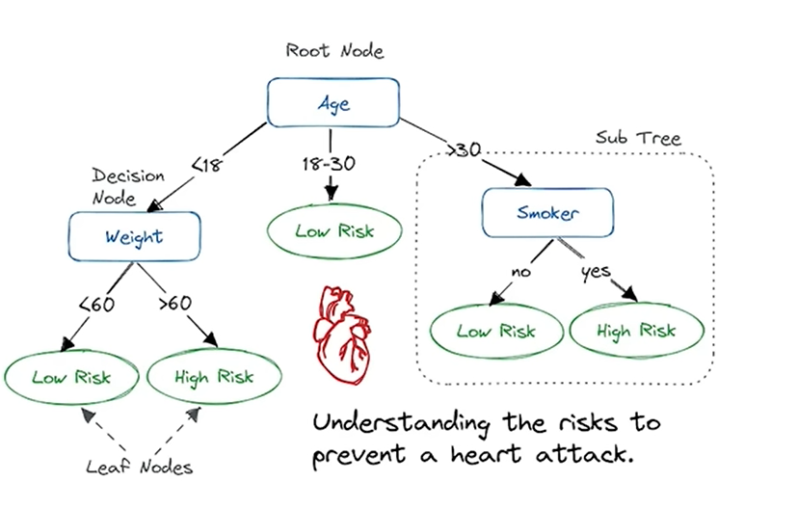
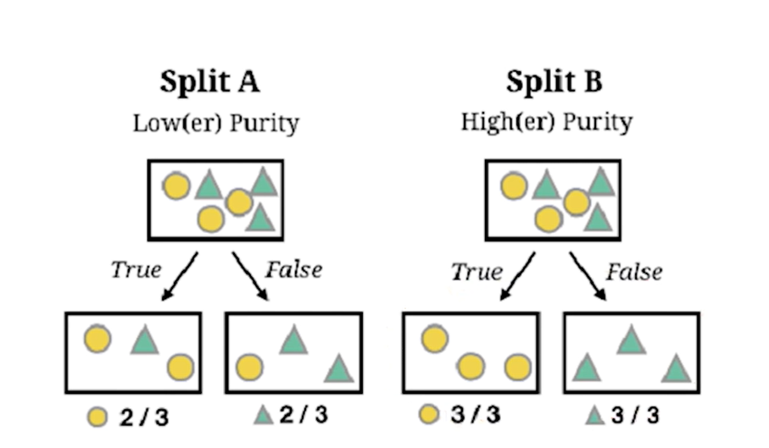
Gradient Boosting works the same way for predictions:
- Start with a simple model (like a tiny decision tree).
- See where it makes mistakes.
- Build another model that tries to correct those mistakes.
- Repeat this many times.
- Add all the models together to make a strong prediction.
It’s like a team of friends guessing your favorite number, each one learning from the mistakes of the previous friend.
If you want, I can draw a tiny visual example that makes it super obvious. Do you want me to do that?
mistakes? how do we know how is it correctewd?
Ah, good question! Let’s break it down carefully.
Here’s how gradient boosting would handle it:
- Start simple:
  - First, the model might make a rough guess for everyone’s insurance charge, like the average of all charges.
  - Obviously, it will be wrong for each person.
- Look at mistakes:
  - For each person, calculate how far off the first guess was from their real charge.
  - Example: Model guessed $5,000, but actual is $7,000 → mistake = $2,000.
- Train a new model on mistakes:
  - The new model looks at BMI, age, gender, smoker and learns patterns in the errors.
  - Maybe it notices: “High BMI people tend to have higher costs than predicted.”
- Add correction to previous prediction:
  - If the second model predicts a $1,800 correction for this person → add to previous $5,000 → new prediction = $6,800.
- Repeat:
  - Each new model focuses on what the previous models still got wrong, gradually improving the predictions.

What is Gradient Boosting Regressor:
- It's an ensemble machine learning algorithm that builds multiple weak prediction models (decision trees) sequentially, where each new tree corrects the errors made by previous trees.
- It uses gradient descent optimization to minimize prediction errors by learning from mistakes - each tree focuses on the residual errors left by the previous trees.
- The algorithm combines all trees' predictions with weighted voting to produce a final, highly accurate prediction.
- Parameters like learning_rate (0.05) control how much each tree contributes, n_estimators (200) sets the number of trees, and max_depth (3) limits tree complexity to prevent overfitting.
Why It's Better Than Other Algorithms:
- Higher Accuracy: Achieves 88% R² score on this dataset, typically outperforming simple Linear Regression, Decision Trees, or Random Forest by 5-15% due to its error-correction mechanism.
- Handles Complex Patterns: Captures non-linear relationships between features (like how smoking + high BMI exponentially increases costs) better than linear models that assume straight-line relationships.
- Feature Importance: Automatically identifies which factors matter most for insurance costs (smoking is likely the strongest predictor), unlike black-box neural networks.
- Robust to Outliers: Less affected by extreme values in the dataset compared to algorithms like K-Nearest Neighbors or Linear Regression, making predictions more reliable for real-world messy data.

"Machine Learning with R", by Brett Lanz - 2013

US only country without healthcare - ensures everyone can access necessary health services without financial hardship
US Healthcare - most hospital denies service if no insuarance
co insuarance - % of insurance + deductibles - money you have to pay despite insurance
BMI - Weight (kg) / Height (m)²
healthy BMI - between 18.5 and 24.9
heart disease, stroke, Type 2 diabetes, and certain cancers
gender - males are at risk of health issues, women constitute nearly half (around 47%) of the labor force, with participation rates generally hovering around 57%
When insurers use in-network hospitals, they pay the hospital less for care.
Children are generally covered under a parent's family plan up to a certain age, often between 18 and 25 years, depending on the insurer and if they are a full-time student. After this age, they must obtain their own policy.

Functions in the Notebook:
- import numpy as np - Imports library for numerical array operations
- import pandas as pd - Imports library for data manipulation and CSV handling
- import joblib - Imports library to save/load trained models as .pkl files
- train_test_split - Splits dataset into 80% training and 20% testing portions
- GradientBoostingRegressor - The main machine learning algorithm that predicts insurance costs
- mean_absolute_error - Calculates average prediction error in dollar terms
- mean_squared_error - Calculates squared error metric (penalizes large mistakes more)
- r2_score - Measures model accuracy as percentage (88% means 88% accurate)
- pd.read_csv() - Loads insurance.csv file into a pandas dataframe
- df.copy() - Creates duplicate of dataset to preserve original data
- df.info() - Shows dataset structure (columns, data types, null values)
- df.describe() - Displays statistical summary (mean, min, max) of numerical columns
- df['charges'] - Accesses the target column containing actual insurance costs
- df['region'].unique() - Lists all unique values in region column (4 regions)
- LabelEncoder() - Converts text categories (male/female) to numbers (0/1)
- fit_transform() - Learns encoding mapping and applies it to convert categories
- X = df[columns] - Selects input features (age, BMI, etc.) for training
- y = df['charges'] - Selects target variable (insurance cost) to predict
- gbr.fit() - Trains the model by learning patterns from training data
- gbr.predict() - Uses trained model to predict insurance cost for new input
- root_mean_squared_error - Calculates RMSE metric showing average prediction error
- insurance_charge_predictor() - Custom function that takes user input and displays predicted costs
- np.array() - Converts user input list into numpy array format
- joblib.dump() - Saves trained model to disk as .pkl file for later use

